Sep 13, 2026

Meeting Sep 13, 2026 at 20:49 SAST
Meeting records Transcript

Summary
Meeting covered deployment progress and database fixes and merge strategies.
Database and Node Versions
Live database functions properly with local updates. Dependencies downgraded for Node version 22.
Pull Request Merging Strategy
Team adopted paired merging approach to clear backlog. Redundant pull requests closed and environment synchronized.
Frontend Deployment and Setup
Frontend deployment initiated with required secrets. Team paused troubleshooting work to resume in morning.

Decisions
Aligned
- Confirmation prompt for assignment saves The team agreed to include a confirmation prompt when saving assignment changes to prevent accidental clicks.
- Lecturer specification of course weekly hours The team confirmed that lecturers will specify the maximum hours per week required for their courses.
- Adding a testing section to the documentation site The team aligned on adding a testing section to the documentation site and documenting how testing is performed using tools like Postman with screenshots.
- Including user feedback in the documentation site The team confirmed that user feedback (via a Google form) and third-party code documentation must be included in the documentation site.
- Streamlined pull request merging process The team agreed that pull request authors must pair with a designated reviewer to merge code after a direct briefing, bypassing general approval delays.
- Functional scope for overflow work The team aligned on defining overflow work as administrative tasks, marking, and invigilation used when tutor staffing is insufficient.

Next steps
- [The group] Reset Databases: Delete local databases and restart the application to enable connectivity with the live database.
- [Kgaogelo G] Fix Availability Feature: Fix the availability application feature to ensure it functions correctly.
- [Mogomotsi Motoma] Add Save Confirmation: Add a confirmation prompt before the save operation in the assignment module to prevent accidental actions.
- [Ndumiso Skhosana] Merge Excuses Feature: Merge the excuses feature branch into the main branch.
- [Tlhale Sebaeng] Fix Database: Resolve database migration and schema synchronization issues across branches.
- [Tlhale Sebaeng] Rename Settings: Rename the settings tab to a more appropriate title and move the logout functionality to a better location.
- [Tlhale Sebaeng] Fix Save Bug: Fix the bug where the save button triggers an action for both event claim fields simultaneously.
- [The group] Add Testing Docs: Add a testing section to the documentation site and include screenshots of Postman API requests.
- [The group] Implement Feedback: Create a Google form for user feedback and incorporate the collected responses into the project documentation.
- [The group] Review Rubric: Audit the application against the rubric to identify missing features and evaluate if the current implementation meets the core project requirements.
- [Tlhale Sebaeng] Approve Task Assignments: Implement approval functionality for task assignment numbers to ensure module capacity compliance.
- [Tlhale Sebaeng] Stop Application Process: Add capability to manually terminate the application process for courses.
- [Tlhale Sebaeng] Update Time Display: Modify time slot interface to display only start and end times.
- [Tlhale Sebaeng] Enable Real-time Approval: Allow lecturers to approve timesheets as tutors submit them.
- [Tlhale Sebaeng] Remove Signature Field: Delete the signature requirement from the timesheet template to streamline the approval process.
- [Tlhale Sebaeng] Implement Overflow Feature: Develop the overflow work functionality for administrative tasks like marking and invigilation.
- [Tlhale Sebaeng] Resolve Merge Conflicts: Address and resolve merge conflicts in existing pull requests to facilitate final integration.
- [Nduvho Mulaudzi] Update Live Database: Update the live database to reflect the latest schema changes.
- [Ndumiso Skhosana] Create Feedback Form: Develop a Google form for user feedback and share it with the team to collect responses.
- [Tlhale Sebaeng] Resolve Conflicts: Fix the existing code conflicts in the branch.
- [Kgaogelo G] Review Implementation: Examine the excuse feature implementation to understand how it was built.
- [Mogomotsi Motoma] Repair Feature: Fix the errors identified in the excuse feature codebase.
- [Kgaogelo G] Add Documentation: Improve code readability by adding comments to the codebase.
- [Nduvho Mulaudzi] Fix Database Issues: Investigate and resolve the database synchronization problems preventing user logins.
- [Mogomotsi Motoma] Debug Unauthorized Access: Analyze the unauthorized errors occurring on the site to restore functionality.
- [Nhlamulo Mabuza] Write Documentation: Draft project documentation including testing details and instructions.
- [Mogomotsi Motoma] Fix Code: Continue code generation or repair after the current process finishes.
- [Kgaogelo G] Implement Excuses: Build the functionality to excuse volunteers from sessions on the main branch.
- [Kgaogelo G] Pull Changes: Merge the excuse feature branch into the main repository.
- [Mogomotsi Motoma] Commit changes: Submit the pending code changes.
- [The group] Attend classes: Participate in all upcoming scheduled lectures.
- [Ndumiso Skhosana] Send notes: Distribute the meeting minutes to the group chat.

Details
- Database and Node Version Updates: Nduvho Mulaudzi reported that the live database is functioning, noting that active users must delete their local databases and restart their systems to connect properly. Additionally, Nduvho Mulaudzi downgraded project dependencies to ensure compatibility with the stable Node version 22 instead of the unstable Node version 26, with these updates housed in a separate branch.
- Tutor Availability and Application Issues: Kgaogelo G raised a bug with Mogomotsi Motoma regarding the "become a tutor" workflow, stating that the interface continuously prompts users to set their availability even after changes are saved. Mogomotsi Motoma maintained that the availability feature previously functioned correctly and displays session options without time conflicts (00:02:31). Tlhale Sebaeng and Kgaogelo G discussed whether this issue originated from the main branch (00:06:57).
- Frontend Error Handling and Status Codes: Kgaogelo G criticized the frontend error handling, stating that login failures occur silently and the frontend only captures status 200 responses (00:06:57). Mogomotsi Motoma and Kgaogelo G discussed backend error management, with Mogomotsi Motoma noting that permission restrictions and non-existent endpoints return standard error codes like 403 or 404 (00:08:09).
- Sprint Timeline and Deadlines: Ndumiso Skhosana noted that the team has a buffer day on Tuesday and evaluation writing scheduled for Thursday (00:10:08). Tlhale Sebaeng and Kgaogelo G debated whether code would be ready for production by Thursday or Friday morning at 6:00 AM (00:11:14).
- Volunteer Application Workflow Debate: Glann Mulaudzi questioned why users must apply to volunteer before viewing available opportunities, arguing that unassigned registered students should directly view an overflow work section (00:15:29) (00:24:39). Tlhale Sebaeng defended the workflow by explaining that volunteering requires filtering candidates based on scheduling criteria to avoid sending expensive and unnecessary emails to 300 students when only a small number of positions are needed (00:19:34). Glann Mulaudzi acknowledged that the team could proceed with their chosen design as long as they were prepared to defend it under scrutiny (00:25:54).
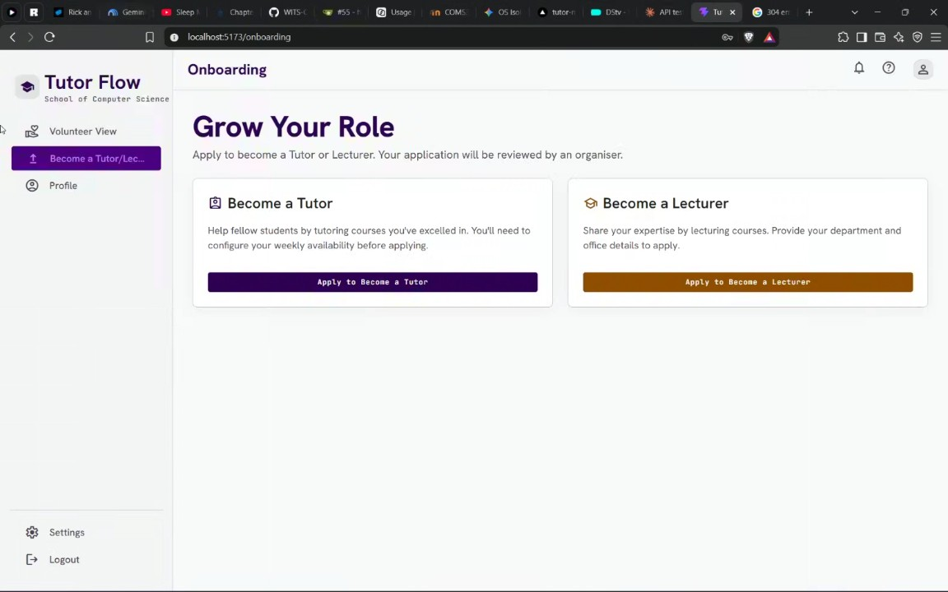
- Timetable Verification and Manual Availability: Glann Mulaudzi expressed concern that allowing users to manually select available time slots without verification could lead to scheduling conflicts during exams (00:28:39). Tlhale Sebaeng argued that developers cannot 100% verify external constraints like marks or personal timetables, which is why the application provides suggestions for human organizers who retain final override authority (00:31:19). Tlhale Sebaeng and Glann Mulaudzi discussed timetable imports as an advanced feature, noting that manual slot adjustments remain necessary to account for extracurricular commitments (00:33:54).
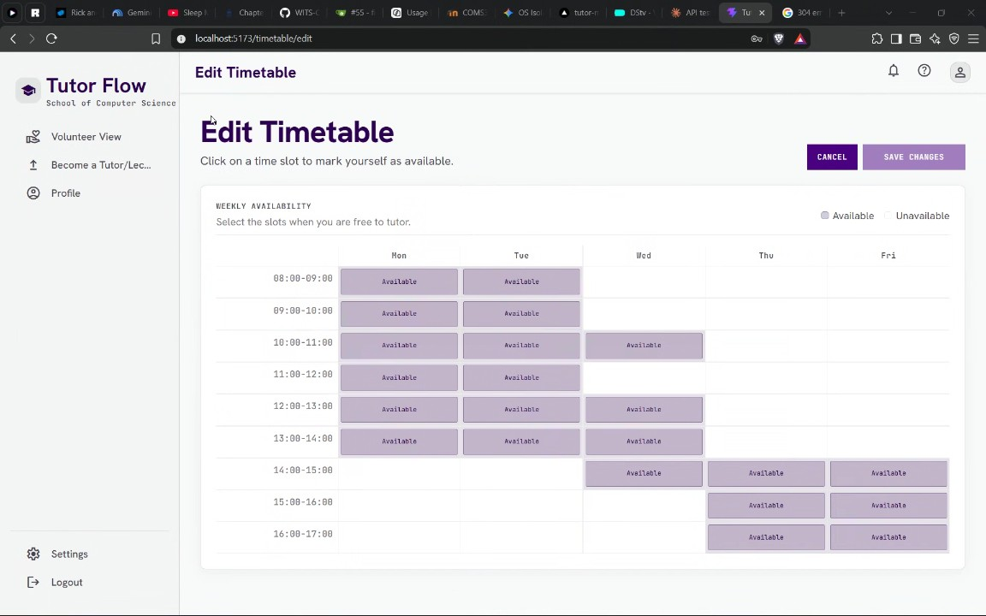
- Lecturer Course Applications and Organizer Assignment Interface: Mogomotsi Motoma demonstrated the lecturer application process where instructors request specific numbers of tutors for courses, subject to organizer approval (00:36:47). Mogomotsi Motoma then presented the organizer assignment interface, showing how organizers allocate tutors to courses and trigger email notifications upon saving (00:38:05). Glann Mulaudzi pointed out the risk of accidental clicks sending removal emails, and Mogomotsi Motoma agreed to add a confirmation prompt to the save action (00:39:42). Mogomotsi Motoma also explained that an "auto" button automatically selects top candidates based on candidate marks (00:40:47).
- Tutor Management Features and Branch Merging Issues: Mogomotsi Motoma reviewed application cards and noted that timesheet features are not yet integrated into the main branch (00:42:14). Glann Mulaudzi asked about tutors excusing themselves, prompting Mogomotsi Motoma and Kgaogelo G to clarify that Ndumiso Skhosana built the feature, but it remains isolated in an unmerged branch (00:43:27). Glann Mulaudzi confirmed with Mogomotsi Motoma that organizers retain the ability to override system rankings and assignments (00:46:48).
- Course Budget Hours and Onboarding Guide: Glann Mulaudzi inquired about specifying hours per course or budget limits, prompting Mogomotsi Motoma and Tlhale Sebaeng to confirm that lecturers specify required weekly hours per course (00:48:55). Glann Mulaudzi suggested adding an onboarding tutorial guide for first-time users, which Mogomotsi Motoma acknowledged as a valid addition to be completed later (00:51:05).
- API Testing and Documentation Format: Mogomotsi Motoma asked Glann Mulaudzi whether API documentation should be presented via a documentation site with screenshots or an interactive endpoint like Swagger. Glann Mulaudzi expressed a preference for an endpoint such as Swagger, and Mogomotsi Motoma sought guidance on whether documentation should be handwritten or autogenerated (00:52:53).
- Database Migrations Across Branches: Tlhale Sebaeng asked for technical assistance regarding Prisma database schema migrations failing when switching between different developer branches. Nhlamulo Mabuza suggested that standard GitHub commands and proper schema management could resolve the issue (00:55:50).
- Documentation Site and Testing Section Requirements: Glann Mulaudzi raised the issue that the team's documentation site lacked a testing section, specifying that testing procedures should be documented by writing requests in Postman and including screenshots (00:57:54). Nhlamulo Mabuza inquired whether any other documentation was required beyond the sprint requirements, and Glann Mulaudzi confirmed that user feedback forms and database documentation were also necessary. When Nhlamulo Mabuza asked about the purpose of the Google Form feedback, Glann Mulaudzi explained it should collect user insights on usability and features to summarize on the documentation site (00:59:15). Because of late-stage timing, Glann Mulaudzi advised the team to create the Google Form themselves, populate it with simulated responses, and document how feedback informed the application (01:00:36).
- Organizer System-Wide Settings: Tlhale Sebaeng shared their screen to demonstrate the application interface, showing that organizers have access to system-wide settings using database tools like Prisma Studio (01:08:50). Tlhale Sebaeng walked through configuring parameters such as maximum claimable hours (set to 3 for testing) and the event claim window (set to 1 month). Glann Mulaudzi and Nhlamulo Mabuza critiqued the label "settings" for organization-wide standards regarding tutor pay and work hours, arguing the name misleadingly suggested personal profile management (01:11:21) (01:14:36). Tlhale Sebaeng acknowledged the naming critique, noting they prioritized core functionality over nomenclature, and agreed with Nhlamulo Mabuza and Glann Mulaudzi that they would find a more appropriate title later (01:12:32).
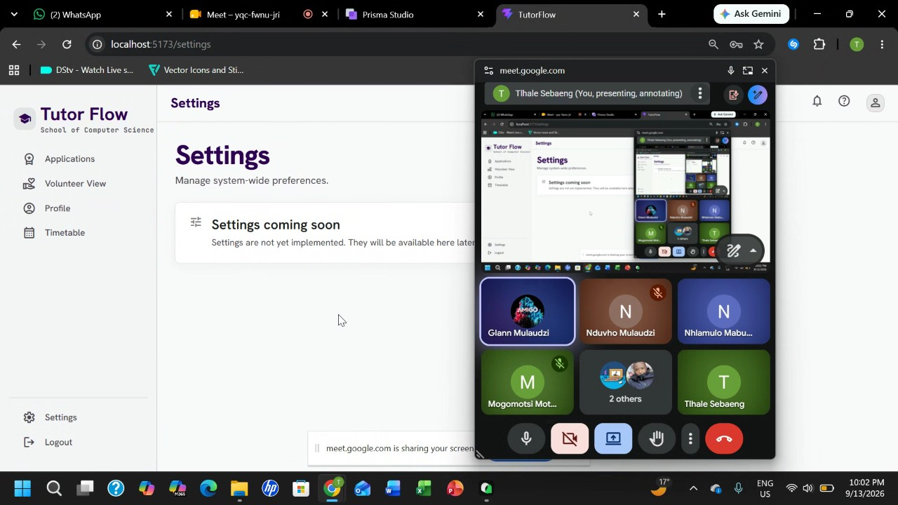
- Hourly Rates and PDF Timesheet Template Automation: Tlhale Sebaeng demonstrated the functionality for setting hourly pay rates by year of study (setting a third-year rate of 133 for testing) to automatically calculate tutor earnings on timesheets (01:14:36). Tlhale Sebaeng explained that the system uses an uploaded PDF payroll template to automatically generate and export finalized timesheets for tutors. Glann Mulaudzi confirmed understanding that tutors log hours, and the system automatically fills out the template to show calculated payouts (01:15:32) (01:17:48).
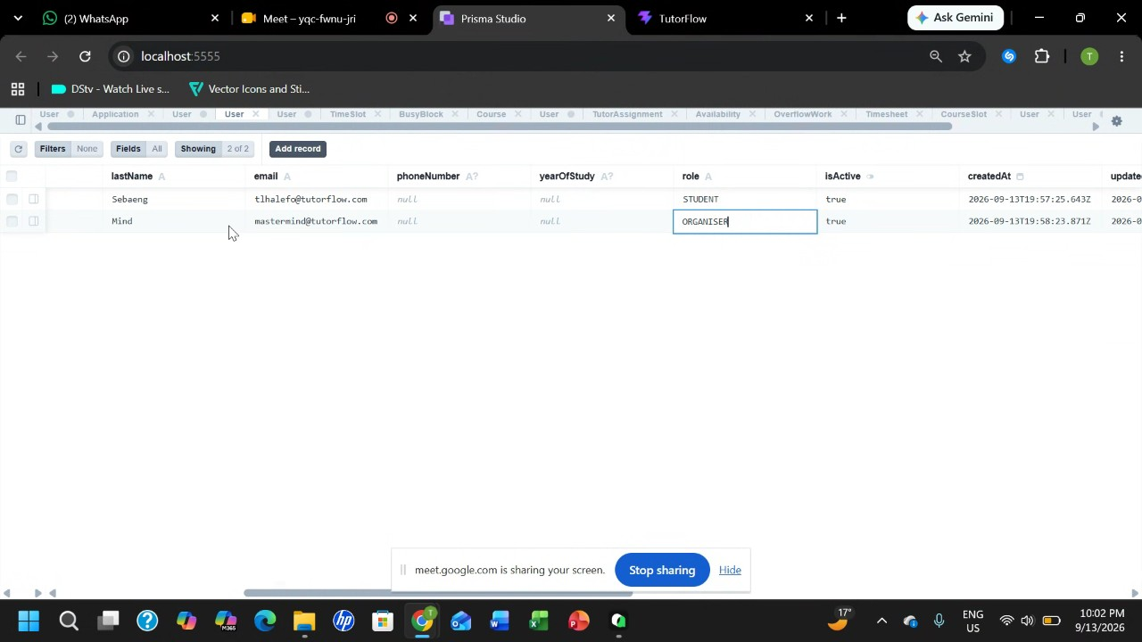
- Student Availability and Project Scope: Tlhale Sebaeng logged in as a student user to show role-specific views, explaining that student profiles focus on setting availability for tutoring opportunities (01:19:10). Glann Mulaudzi asked about course visibility across different university schools, prompting Tlhale Sebaeng to clarify that the application is specifically built for the School of Computer Science and Applied Math according to the project brief, and that any non-matching modules displayed earlier were merely dummy data (01:21:01).
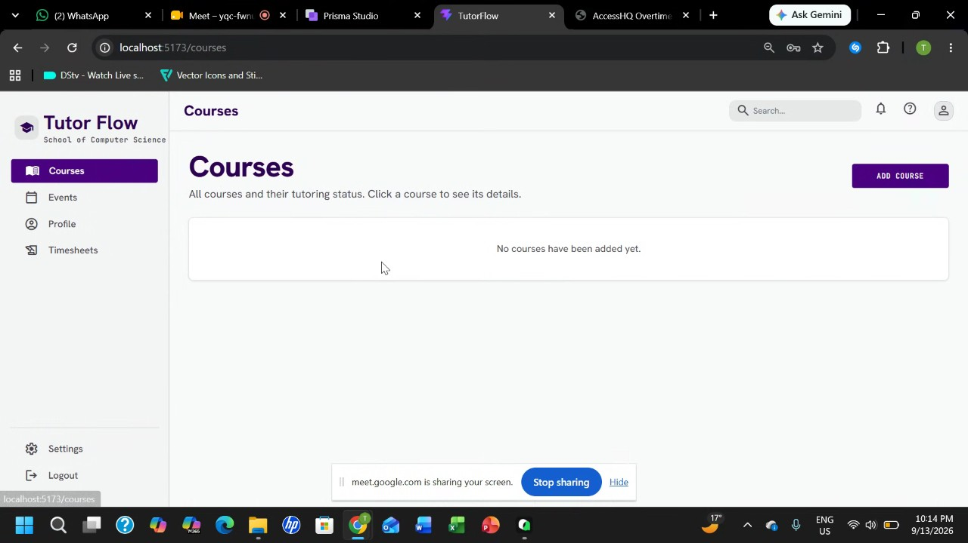
- Lecturer Course Creation and Slot Management: Tlhale Sebaeng logged in as a lecturer to demonstrate adding a course, specifying a minimum required mark of 65 percent, requiring 10 tutors, and assigning specific time slots for Parallel Computing (01:22:17) (01:29:10). After resolving rendering bugs by running a database seed script, Tlhale Sebaeng explained that time slots are fixed via code and database seeding rather than custom user entry to maintain scheduling consistency (01:26:53). Glann Mulaudzi inquired about timetable export features, and Tlhale Sebaeng noted that importing from a timetable is planned but not yet implemented (01:29:10).
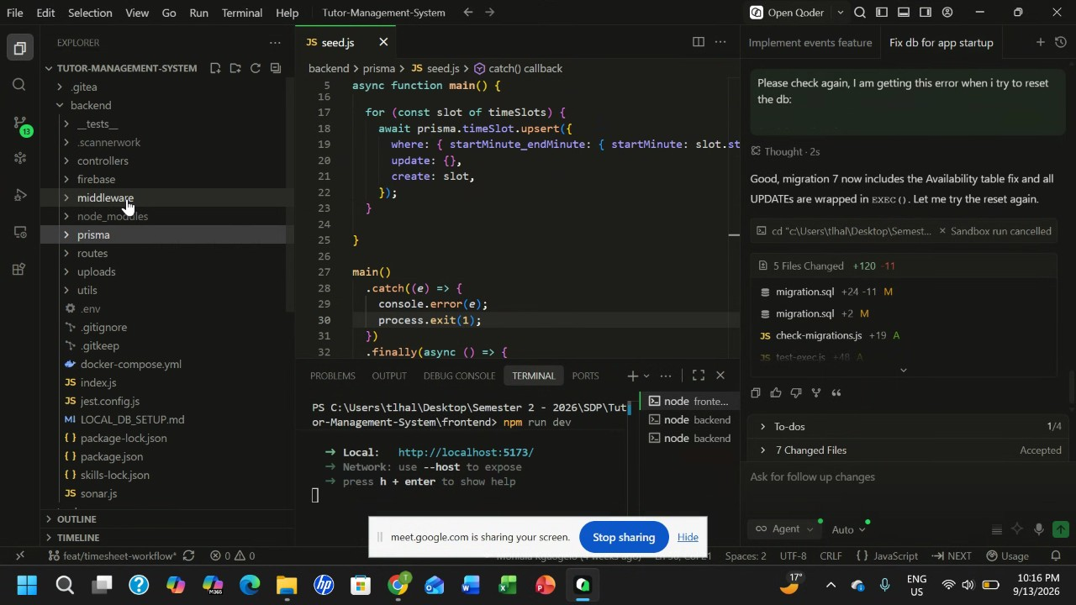
- Course Application Approval Workflow: Glann Mulaudzi raised a concern that lecturers should not be able to independently launch applications and dictate tutor quantities without organizer review and approval (01:31:45). Tlhale Sebaeng acknowledged the oversight, agreed that organizer oversight is necessary, and committed to adding a pending review status and manual application closing features in future updates (01:33:16).
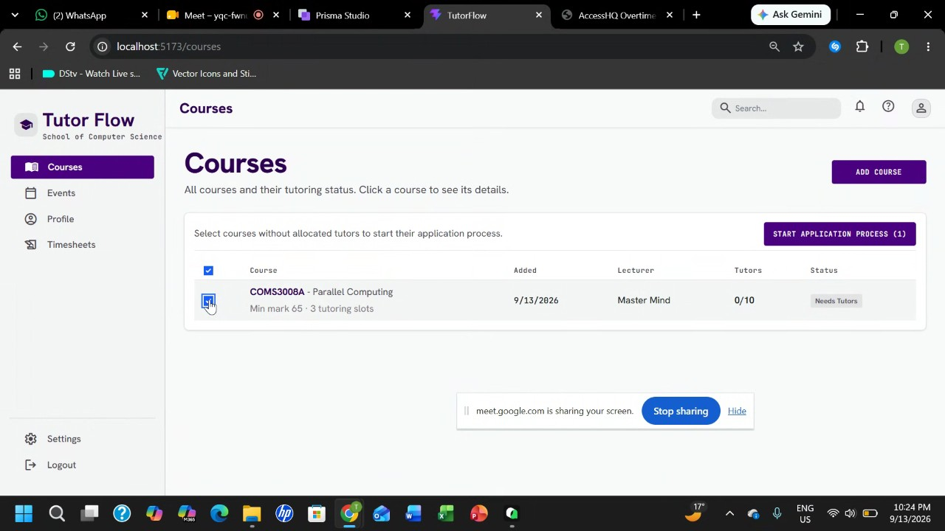
- Student Application Process and Timetable Lock: Tlhale Sebaeng logged back in as a student to demonstrate how course applications are filtered by user availability, noting that opportunities only appear if a student's timetable matches the course schedule (01:34:38). Tlhale Sebaeng showed that after meeting the minimum mark requirement (entering 70 against a 65 requirement) and submitting an application, the student's timetable selection for that slot becomes locked to prevent scheduling inconsistencies while pending approval (01:37:12).
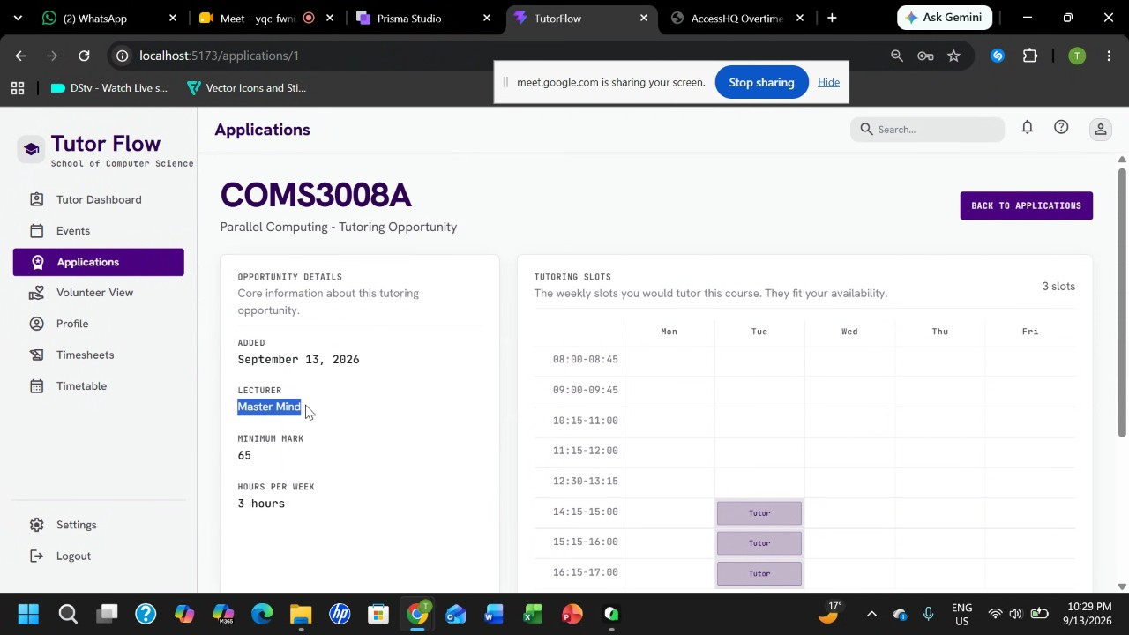
- Maximum Weekly Claimable Hour Enforcement: Tlhale Sebaeng demonstrated the system's enforcement of claimable hour limits when a student attempts to apply for a second course that exceeds the maximum limit of 3 hours per week (01:43:26). When test applicant user data brought the total to 6 hours, the system successfully blocked the application and displayed a warning message stating that the hours exceeded the maximum claimable limit. Glann Mulaudzi reviewed the logic, and Tlhale Sebaeng confirmed the system handles limit validation properly (01:44:54).
- Event Creation for Timesheet Automation: Tlhale Sebaeng explained that lecturers can create scheduled events linked to specific courses to help tutors claim hours and automate timesheet generation (01:47:01). Glann Mulaudzi suggested incorporating a secret verification code for event attendance to replace manual supervisor sign-offs, and Tlhale Sebaeng agreed that advanced attendance and automated signature verification would be implemented later (01:49:39).
- Timesheet Submission and Approval Workflow: Tlhale Sebaeng demonstrated the timesheet workflow where a lecturer creates an event for Parallel Computing on September 1st, allowing allocated tutors to view it (01:50:47). Tlhale Sebaeng showed that tutors can create a timesheet, add past claim events, update titles in real time, and submit the timesheet for approval, after which it locks against further edits. Finally, Tlhale Sebaeng logged into the supervisor view, demonstrating that supervisors can review submitted timesheets and choose to either approve or reject them (01:53:06) (01:55:31).
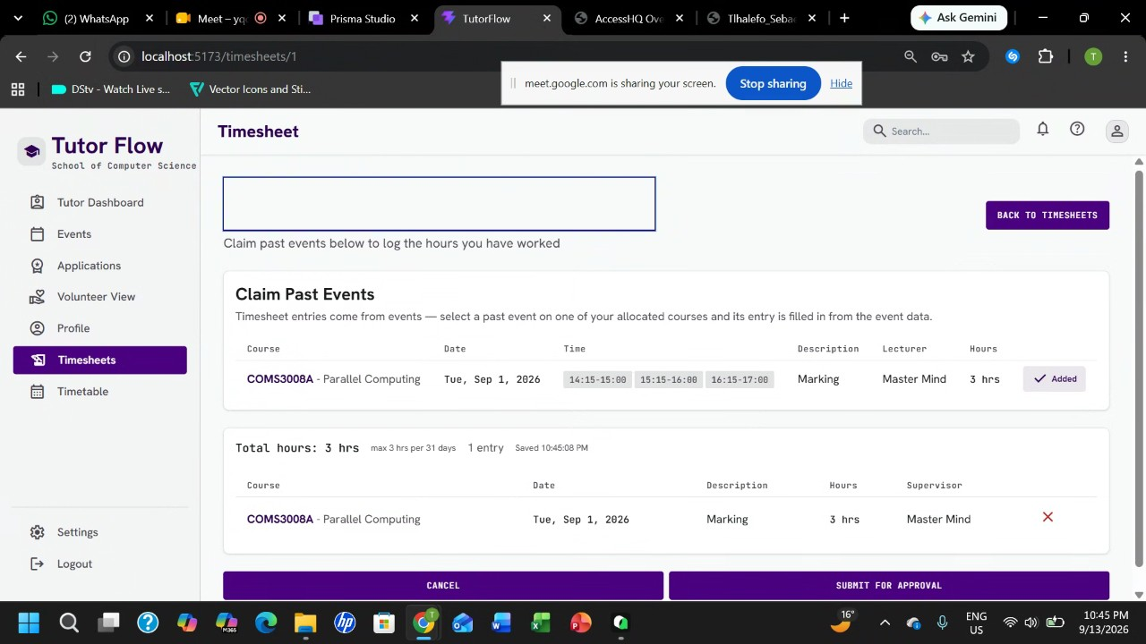
- Time Sheet Approval Workflow and Signature Requirements: Tlhale Sebaeng and Glann Mulaudzi discuss the mechanism for lecturer time sheet approvals, noting that time sheets require approval from relevant lecturers and that a rejection by any single lecturer results in the rejection of the entire time sheet (01:56:41). Glann initially suggests removing physical signature requirements since the web application digitally tracks approvals (01:57:57). However, Glann later argues that payroll lacks direct access to the web application and will still require a supervisor's physical signature on the PDF time sheet. Tlhale mentions they could make the PDF accessible to payroll if necessary (02:00:43), but Glann emphasizes that payroll handles diverse claims and will not use the web system directly. The team concludes that signature requirements must align with payroll's operational needs (01:57:57) (02:02:23).
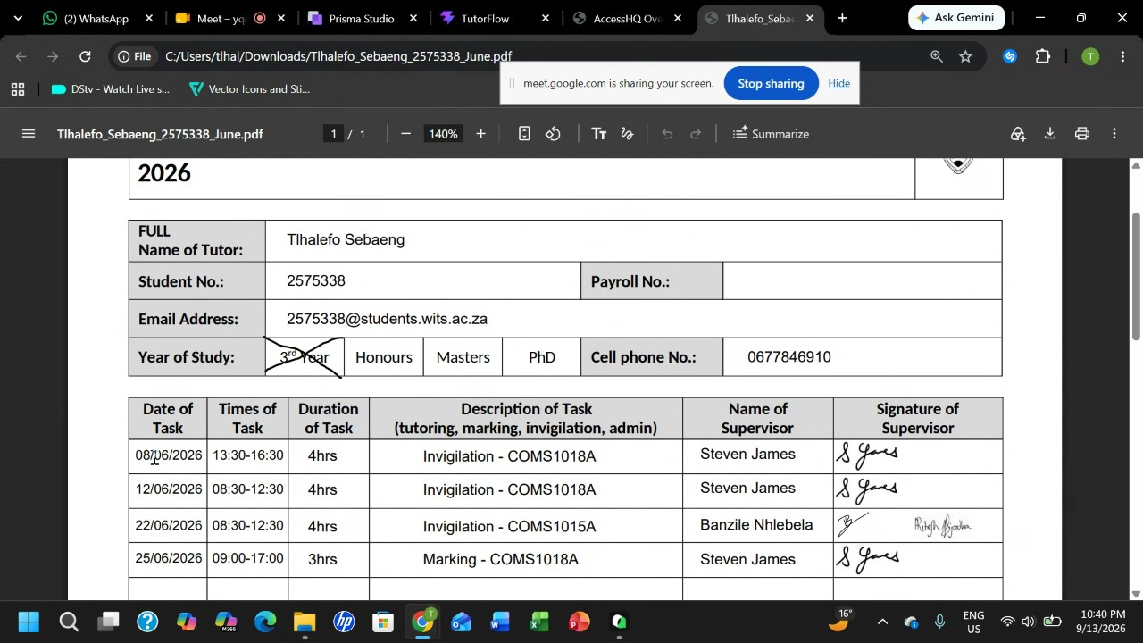
- Student Time Sheet PDF Export Feature: Tlhale Sebaeng demonstrates the student-facing interface, showing that students can view their approved time sheets and use an export button to download the data as a PDF. Glann Mulaudzi acknowledges that the feature correctly populates data for payroll processing (01:59:03).
- Pull Review and Merging Strategy: Nduvho Mulaudzi, Tlhale Sebaeng, Kgaogelo G, and Nhlamulo Mabuza address a backlog of 10 to 11 open pull requests with merge conflicts and slow approval times. Nduvho notes that the first pull request merged must fix main branch issues before other merge conflicts can be resolved (02:05:35). Nhlamulo suggests a streamlined process where each pull request author pairs with another team member to explain critical details and execute the merge directly, bypassing delays from waiting for multiple formal approvals. The team agrees to adopt this paired merging approach to clear the backlog (02:07:27).
- Definition and Implementation of Overflow Work: Tlhale Sebaeng asks Mogomotsi Motoma to clarify the requirements for overflow work (02:13:01). Mogomotsi explains that overflow work is designated for administrative tasks, marking, and invigilation when there is a shortage of tutors (02:14:34). Kgaogelo G raises questions about whether volunteers constitute a distinct category or if overflow work should be assigned to existing tutors (02:30:11). Nduvho Mulaudzi and Mogomotsi clarify that volunteers are not a separate group of people, but rather existing tutors who step in during overflow situations (02:31:40). Tlhale plans to implement the overflow feature based on administrative tasks and tutor availability (02:14:34).
- Pull Request Cleanup and Database Schema Updates: Mogomotsi Motoma and Nduvho Mulaudzi review multiple open pull requests concerning documentation, database schemas, and course management features (02:16:02). Nduvho expresses confusion regarding schema update branches and database synchronization (02:18:49), while discussing whether features allowing lecturers to add courses are already included in recent master pull requests (02:22:22). Nduvho and Mogomotsi also review deployment workflow modifications and SonarQube test execution (02:24:44). The team decides to close redundant pull requests, merge updated read-me documentation and schema changes, and pull from the main branch to synchronize their working environments (02:18:49).
- Tutor Excuse Feature and Handover: Kgaogelo G explains that the excuse feature needs to track how many tutors excuse themselves from a session so that if a threshold is exceeded, the shift can be opened up for volunteering (02:35:18). Ndumiso Skhosana states that their computing credits are running low and they need to focus on other tasks, asking if another team member can take over fixing the broken excuse feature branch. Mogomotsi Motoma volunteers to take over the feature implementation (02:45:13).
- Local Environment and Database Troubleshooting: Nduvho Mulaudzi and Kgaogelo G test the main branch and encounter login failures and unauthorized error messages (02:46:57). Nduvho suggests that the issues stem from local storage and out-of-sync local databases (02:48:49). Kgaogelo notes that signing up also fails and backend logs display unauthorized statuses (02:50:33). The team identifies local database synchronization as the root cause of the login and authentication failures (02:48:49).
- Frontend Deployment Workflow Issues: Mogomotsi Motoma reports that frontend changes are not deploying automatically because the deployment workflow is incomplete and terminal commands route incorrectly to Vercel (02:50:33). Nduvho Mulaudzi reviews the workflow configuration files and questions why frontend build steps are present without a corresponding deployment step. Mogomotsi explains that dependencies are installed and the frontend is built, but the deployment action is missing from the workflow. The team discusses updating the workflow configuration to ensure proper automated frontend deployment (02:52:00).
- Frontend Deployment Configuration: Nduvho Mulaudzi stated that their team needed secrets, specifically the cell project ID and cell token, for frontend deployment. Ndumiso Skhosana requested that they create a Google form to collect user feedback. Nduvho Mulaudzi later confirmed that deployment to the frontend was in progress (02:53:47).
- Operating Systems Concepts Discussion: Kgaogelo G and Mogomotsi Motoma debated operating systems concepts, discussing whether context switching occurs between processes or threads. Kgaogelo G argued that processes do not run directly, but rather run via threads, which utilize a Thread Control Block instead of a Process Control Block for kernel pointers (02:59:56). Mogomotsi Motoma questioned these assertions, while Kgaogelo G noted they consulted Gemini regarding kernel pointer locations (03:01:06).
- Frontend Interface and Navigation Shortcuts: Ndumiso Skhosana reminded participants to complete the user feedback form. Mogomotsi Motoma and Nduvho Mulaudzi observed that the frontend interface was currently blank (03:03:10). To navigate codebases efficiently, Kgaogelo G inquired about shortcut keys, and Mogomotsi Motoma explained that pressing control and left-clicking on a file controller directs users to specific code sections (03:05:09).
- Academic Progress and University Applications: Mogomotsi Motoma claimed to be studying Operating Systems chapter six, which Nduvho Mulaudzi and Kgaogelo G disputed by pointing out there are only six chapters in total (03:06:43). Additionally, Kgaogelo G and Mogomotsi Motoma discussed university honors application fees and the status of application deadlines (03:07:56).
- Git Conflict Resolution and API Integration: Tlhale Sebaeng committed to resolving merge conflicts in their branch and adding comments to improve code readability before resting. Nduvho Mulaudzi and Kgaogelo G discussed implementing a tutorial walkthrough feature that displays click instructions upon opening the site for the first time (03:09:34). Kgaogelo G raised the topic of deploying an external API endpoint, which Mogomotsi Motoma and Nduvho Mulaudzi discussed in relation to backend data exposure (03:10:51).
- Project Timelines and Deployment Status: Mogomotsi Motoma and Nduvho Mulaudzi reviewed project schedules, noting that an operating system project has approximately 20 days remaining, while a Triple A project is due in 40 days (03:12:25). Nduvho Mulaudzi verified that a deployment had successfully executed and shared the domain link (03:13:48).
- Server Authorization and API Key Errors: Kgaogelo G reported encountering 401 unauthorized server errors across their system (03:15:42). Mogomotsi Motoma encountered a Firebase error indicating an invalid API key after code changes were introduced. Nduvho Mulaudzi denied responsibility for the Firebase error, prompting the group to troubleshoot the issue (03:16:54).
- Main Branch Context Loss and Time Tracking: Tlhale Sebaeng identified that context data was missing on the main branch and that file extensions had been changed from JSX to JavaScript, causing merge conflicts (03:18:20). Tlhale Sebaeng worked on accepting current changes and resolving conflicts across multiple files. Meanwhile, Nduvho Mulaudzi noted that the meeting call had been active for three hours (03:19:27).
- Data Seeding and Environment Setup: Tlhale Sebaeng and Mogomotsi Motoma debated the necessity of database seeding for synthetic users and course data, with Mogomotsi Motoma arguing that implementations require data to function (03:22:56). Nduvho Mulaudzi instructed Kgaogelo G to check their Node Version Manager version, which Kgaogelo G confirmed as version 24.0, and shared troubleshooting screenshots via group chat (03:24:48).
- Participant Fatigue and Branch Merging: Participants observed that Nhlamulo Mabuza had fallen asleep during the call (03:27:28). Tlhale Sebaeng pushed their branch changes after attempting to minimize merge conflicts, warning others that testing the code would require care. Kgaogelo G requested that Tlhale Sebaeng also handle volunteer-related merges (03:30:21).
- Dependency Installation Failures and Code Execution: Tlhale Sebaeng experienced dependency installation failures due to missing updates in the lock file for their new commit (03:32:18). Kgaogelo G utilized the AI tool Koda to input code snippets, successfully resolving their system access issues while other participants requested assistance for Nhlamulo Mabuza's branch (03:35:53).
- Documentation Responsibilities: After waking up, Nhlamulo Mabuza addressed concerns about documentation, committing to take responsibility for writing the project documentation (03:38:21). Nhlamulo Mabuza stated that they would compile fake responses for the user feedback form and incorporate testing details once the application build and deployment were fully completed (03:42:36).
- Academic Future and Postgraduate Studies: Mogomotsi Motoma, Kgaogelo G, and Nduvho Mulaudzi discussed their ambitions to pursue Master's degrees and honors programs, noting that supervisors would include departmental lecturers and relevant teaching assistants (03:41:27). The group also noted that Benedict had withdrawn from the subcommittee because the work was not suitable for them (03:42:36).
- Role Selection and Database Management: Kgaogelo G and Nhlamulo Mabuza discussed system user roles, pointing out that role selection during sign-up was missing and that student and tutor application logic needed clarification (03:43:50). Nhlamulo Mabuza suggested opening the live database to manually update user roles or utilizing multiple admin accounts, while Nduvho Mulaudzi and Mogomotsi Motoma continued troubleshooting frontend rendering errors on specific branches (03:45:58).
- Concluding Remarks and Wrapping Up: Mogomotsi Motoma and Nduvho Mulaudzi addressed ongoing code generation tasks and white screen rendering issues (03:48:40). Acknowledging fatigue, participants including Mogomotsi Motoma, Nduvho Mulaudzi, and Kgaogelo G agreed to pause their work and resume troubleshooting in the morning (03:50:01).
- Branch Merging and Schema Dependencies: The team discusses merging the volunteer, bargain, and telephone branches. Kgaogelo G explains that merging these branches requires altering the database schema and workflow, and cannot proceed without the telephone branch. While Nhlamulo Mabuza urges an immediate merge, Mogomotsi Motoma and Kgaogelo G note that the branches are currently non-functional and cannot be merged yet (03:51:10). The group agrees to delay the merging process until the underlying issues and schema dependencies are resolved (03:52:10).
- Profiles Page Planning and Interface Design: The participants plan to work on the profiles page—covering names, surnames, and website colors—during the next sprint. Nhlamulo Mabuza claims the role of front-end designer, which Kgaogelo G disputes by arguing that the project is too small to warrant a dedicated front-end design position (03:53:27). Later, Mogomotsi Motoma shares their screen to display an AI-generated website layout, which Ndumiso Skhosana and Nduvho Mulaudzi find visually appealing and well-organized (03:54:33).
- Website Dashboard and Volunteer Session Data: Mogomotsi Motoma demonstrates that they have fixed the Twitter dashboard on the miss branch. The group reviews the displayed data to determine if the sessions are active, and Mogomotsi Motoma highlights a logic error where the interface states that only students can volunteer for unassigned sessions (03:55:40). To address this, Kgaogelo G plans to build volunteer-counting functionality on top of the current setup to correctly display sessions that require volunteers (03:58:19).
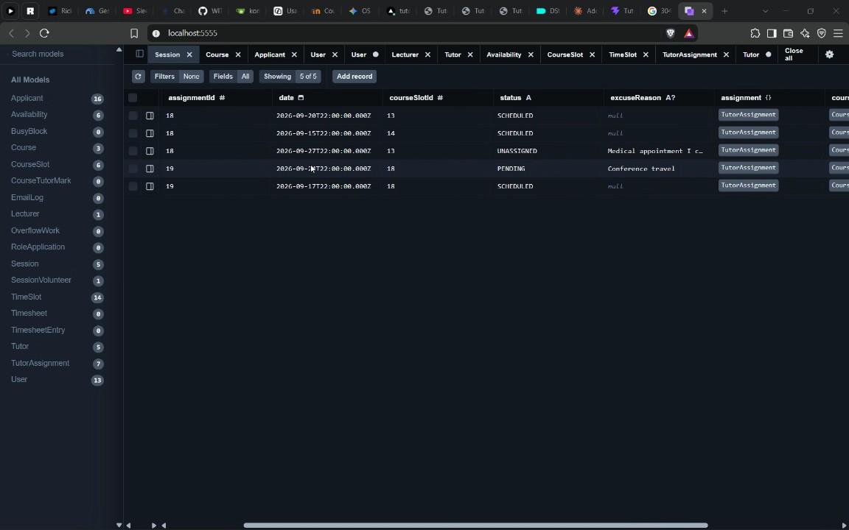
- Tutor Dashboard Excuse Feature and Task Timeline: Mogomotsi Motoma outlines requirements for tutor-specific sessions on the Twitter dashboard, explaining that tutors should be able to view their upcoming sessions and select an option to excuse themselves with a reason (04:01:07). Following a discussion about the call lasting over five hours, Mogomotsi Motoma commits to properly prompting and updating the code overnight, while other participants discuss their plans to study or sleep (03:59:42) (04:02:25).
- Undergraduate Class Attendance and Career Value Debate: Mogomotsi Motoma urges the participants to consistently attend all classes starting Wednesday for their final block of undergraduate studies (04:04:27). This prompts a debate among Mogomotsi Motoma, Nduvho Mulaudzi, Ndumiso Skhosana, and Kgaogelo G regarding the value of pursuing a Master's degree versus entering the job market directly as coders, touching on graduate salary expectations such as a 20k figure mentioned by Nduvho Mulaudzi (04:05:25). As the call concludes, Ndumiso Skhosana notes that the website is operational, ends the meeting, and agrees to format and share the meeting notes on the group chat (04:08:03).

You should review Gemini's notes to make sure they're accurate. Get tips and learn how Gemini takes notes
How is the quality of these specific notes? Take a short survey to let us know your feedback, including how helpful the notes were for your needs.

